Bubble Sort-

- Bubble sort is the easiest sorting algorithm to implement.
- It is inspired by observing the behavior of air bubbles over foam.
- It is an in-place sorting algorithm.
- It uses no auxiliary data structures (extra space) while sorting.

How Bubble Sort Works?

- Bubble sort uses multiple passes (scans) through an array.
- In each pass, bubble sort compares the adjacent elements of the array.
- It then swaps the two elements if they are in the wrong order.

SORTING ALGORITHM
14 December y
- In each pass, bubble sort places the next largest element to its proper position.
14 December y
- In short, it bubbles down the largest element to its correct position.

Bubble Sort Algorithm-

The bubble sort algorithm is given below-

for(int pass=1 ; pass<=n-1 ; ++pass) // Making passes through array
{
for(int i=0 ; i<=n-2 ; ++i)
{
if(A[i] > A[i+1]) // If adjacent elements are in wrong order
swap(i,i+1,A); // Swap them
}
}
//swap function : Exchange elements from array A at position x,y
void swap(int x, int y, int[] A)
{
int temp = A[x];
A[x] = A[y];
A[y] = temp;
return ;
}
// pass : Variable to count the number of passes that are done till now
// n : Size of the array
// i : Variable to traverse the array A
// swap() : Function to swap two numbers from the array
// x,y : Indices of the array that needs to be swapped

Bubble Sort Example-

Consider the following array A-

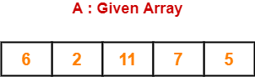

Now, we shall implement the above bubble sort algorithm on this array.

Step-01:

- We have pass=1 and i=0.
- We perform the comparison A[0] > A[1] and swaps if the 0th element is greater than the 1th element.
- Since 6 > 2, so we swap the two elements.

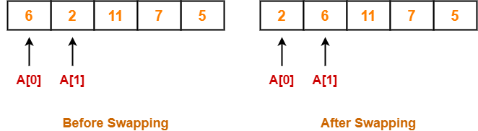

Step-02:

- We have pass=1 and i=1.
- We perform the comparison A[1] > A[2] and swaps if the 1th element is greater than the 2th element.
- Since 6 < 11, so no swapping is required.

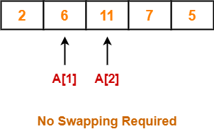

Step-03:

- We have pass=1 and i=2.
- We perform the comparison A[2] > A[3] and swaps if the 2nd element is greater than the 3rd element.
- Since 11 > 7, so we swap the two elements.

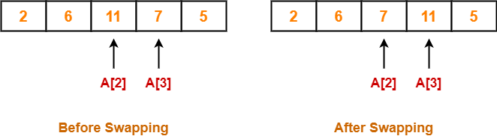

Step-04:

- We have pass=1 and i=3.
- We perform the comparison A[3] > A[4] and swaps if the 3rd element is greater than the 4th element.
- Since 11 > 5, so we swap the two elements.

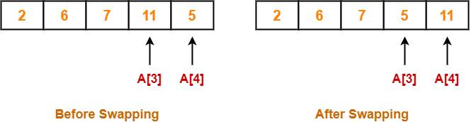

Finally after the first pass, we see that the largest element 11 reaches its correct position.

Step-05:

- Similarly after pass=2, element 7 reaches its correct position.
- The modified array after pass=2 is shown below-

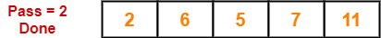

Step-06:

- Similarly after pass=3, element 6 reaches its correct position.
- The modified array after pass=3 is shown below-

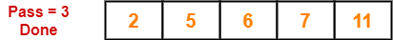

Step-07:

- No further improvement is done in pass=4.
- This is because at this point, elements 2 and 5 are already present at their correct positions.
- The loop terminates after pass=4.
- Finally, the array after pass=4 is shown below-

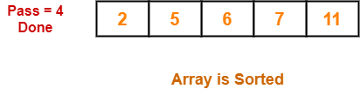

Time Complexity Analysis-

- Bubble sort uses two loops- inner loop and outer loop.
- The inner loop deterministically performs O(n) comparisons.

Worst Case-

- In worst case, the outer loop runs O(n) times.
- Hence, the worst case time complexity of bubble sort is O(n x n) = O(n2).

Best Case-

- In best case, the array is already sorted but still to check, bubble sort performs O(n) comparisons.
- Hence, the best case time complexity of bubble sort is O(n).

Average Case-

- In average case, bubble sort may require (n/2) passes and O(n) comparisons for each pass.
- Hence, the average case time complexity of bubble sort is O(n/2 x n) = Θ(n2).

The following table summarizes the time complexities of bubble sort in each case-

 | Time Complexity
Best Case | O(n)
Average Case | Θ(n²)
Worst Case | O(n²)

From here, it is clear that bubble sort is not at all efficient in terms of time complexity of its algorithm.

Space Complexity Analysis-

- Bubble sort uses only a constant amount of extra space for variables like flag, i, n.
- Hence, the space complexity of bubble sort is O(1).
- It is an in-place sorting algorithm i.e. it modifies elements of the original array to sort the given array.

Properties-

Some of the important properties of bubble sort algorithm are-
- Bubble sort is a stable sorting algorithm.
- Bubble sort is an in-place sorting algorithm.
- The worst case time complexity of bubble sort algorithm is O(n2).
- The space complexity of bubble sort algorithm is O(1).
- Number of swaps in bubble sort = Number of inversion pairs present in the given array.
- Bubble sort is beneficial when array elements are less and the array is nearly sorted.

Merge Sort-

- Merge sort is a famous sorting algorithm.
- It uses a divide and conquer paradigm for sorting.
- It divides the problem into sub problems and solves them individually.
- It then combines the results of sub problems to get the solution of the original problem.

How Merge Sort Works?

Before learning how merge sort works, let us learn about the merge procedure of merge sort algorithm.
The merge procedure of merge sort algorithm is used to merge two sorted arrays into a third array in sorted order.

Consider we want to merge the following two sorted sub arrays into a third array in sorted order-

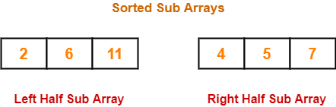

The merge procedure of merge sort algorithm is given below-

// L : Left Sub Array , R : Right Sub Array , A : Array
merge(L, R, A)
{
nL = length(L) // Size of Left Sub Array
nR = length(R) // Size of Right Sub Array
i = j = k = 0
while(i<nL && j<nR)
{
/* When both i and j are valid i.e. when both the sub arrays have elements to insert in A */
if(L[i] <= R[j])
{
A[k] = L[i]
k = k+1
i = i+1
}
else
{
A[k] = R[j]
k = k+1
j = j+1
}
}
// Adding Remaining elements from left sub array to array A
while(i<nL)
{
A[k] = L[i]
i = i+1
k = k+1
}
// Adding Remaining elements from right sub array to array A
while(j<nR)
{
A[k] = R[j]
j = j+1
k = k+1
}
}

The above merge procedure of merge sort algorithm is explained in the following steps-

Step-01:

- Create two variables i and j for left and right sub arrays.
- Create variable k for sorted output array.
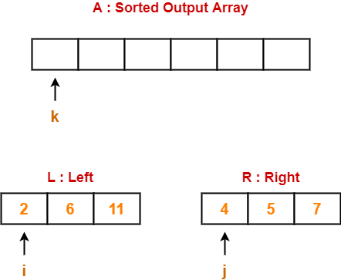

Step-02:

- We have i = 0, j = 0, k = 0.
- Since L[0] < R[0], so we perform A[0] = L[0] i.e. we copy the first element from left sub array to our sorted output array.
- Then, we increment i and k by 1.

Then, we have-

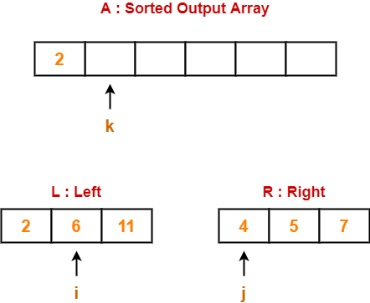

Step-03:

- We have i = 1, j = 0, k = 1.
- Since L[1] > R[0], so we perform A[1] = R[0] i.e. we copy the first element from right sub array to our sorted output array.
- Then, we increment j and k by 1.

Then, we have-

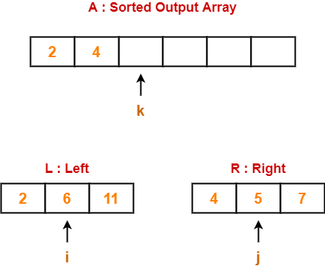

Step-04:

- We have i = 1, j = 1, k = 2.
- Since L[1] > R[1], so we perform A[2] = R[1].
- Then, we increment j and k by 1.

Then, we have-

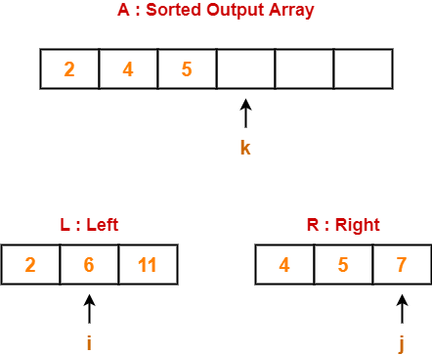

Step-05:

- We have i = 1, j = 2, k = 3.
- Since L[1] < R[2], so we perform A[3] = L[1].
- Then, we increment i and k by 1.

Then, we have-

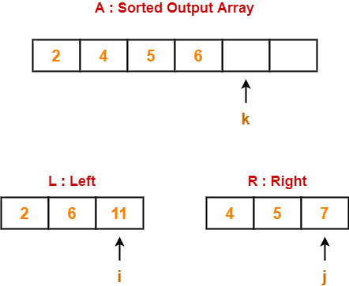

Step-06:

- We have i = 2, j = 2, k = 4.
- Since L[2] > R[2], so we perform A[4] = R[2].
- Then, we increment j and k by 1.

Then, we have-

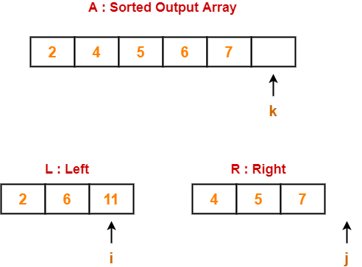

Step-07:

- Clearly, all the elements from right sub array have been added to the sorted output array.
- So, we exit the first while loop with the condition while(i<nL && j<nR) since now j>nR.
- Then, we add remaining elements from the left sub array to the sorted output array using next while loop.

Finally, our sorted output array is-

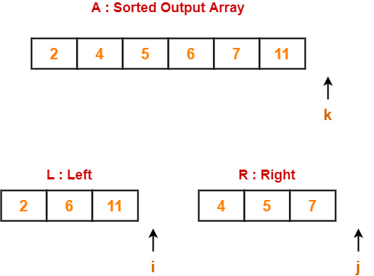

Basically,
- After finishing elements from any of the sub arrays, we can add the remaining elements from the other sub array to our sorted output array as it is.
- This is because left and right sub arrays are already sorted.

Time Complexity
The above mentioned merge procedure takes Θ(n) time.
This is because we are just filling an array of size n from left & right sub arrays by incrementing i and j at most Θ(n) times.

Merge Sort Algorithm-

Merge Sort Algorithm works in the following steps-
- It divides the given unsorted array into two halves- left and right sub arrays.
- The sub arrays are divided recursively.
- This division continues until the size of each sub array becomes 1.
- After each sub array contains only a single element, each sub array is sorted trivially.
- Then, the above discussed merge procedure is called.
- The merge procedure combines these trivially sorted arrays to produce a final sorted array.

The division procedure of merge sort algorithm which uses recursion is given below-

// A : Array that needs to be sorted
MergeSort(A)
{
n = length(A)
if n<2 return
mid = n/2
left = new_array_of_size(mid) // Creating temporary array for left
right = new_array_of_size(n-mid) // and right sub arrays
for(int i=0 ; i<=mid-1 ; ++i)
{
left[i] = A[i] // Copying elements from A to left
}
for(int i=mid ; i<=n-1 ; ++i)
{
right[i-mid] = A[i] // Copying elements from A to right
}
MergeSort(left) // Recursively solving for left sub array
MergeSort(right) // Recursively solving for right sub array
merge(left, right, A) // Merging two sorted left/right sub array to final array
}

Merge Sort Example-

Consider the following elements have to be sorted in ascending order-
6, 2, 11, 7, 5, 4

The merge sort algorithm works as-

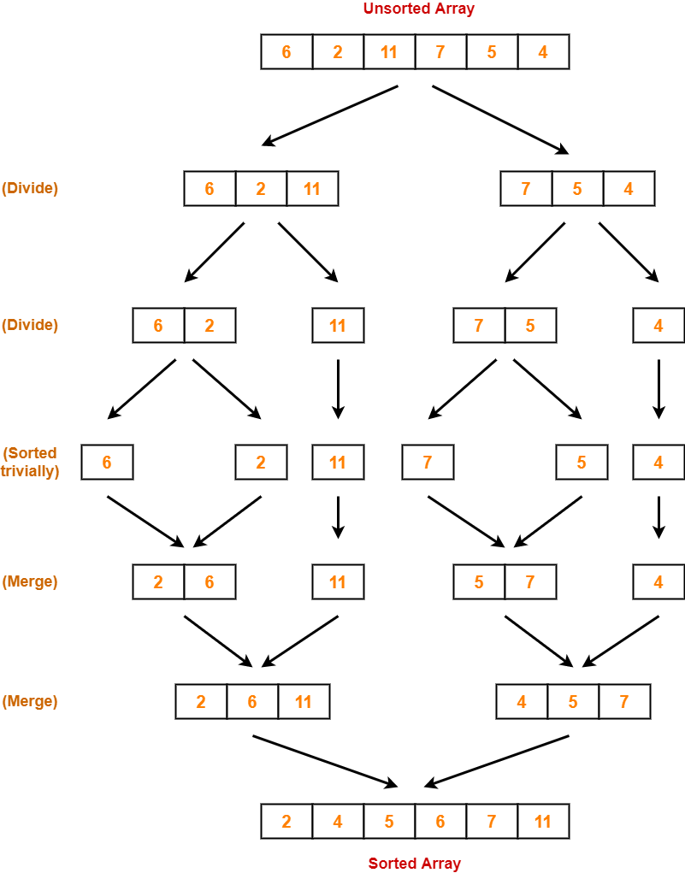

Time Complexity Analysis-

In merge sort, we divide the array into two (nearly) equal halves and solve them recursively using merge sort only.
So, we have-

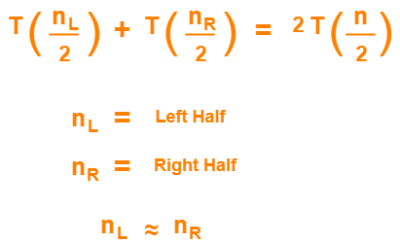

Finally, we merge these two sub arrays using merge procedure which takes Θ(n) time as explained above.

If T(n) is the time required by merge sort for sorting an array of size n, then the recurrence relation for time complexity of merge sort is-

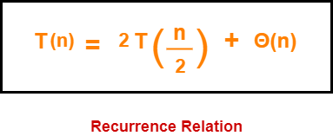

On solving this recurrence relation, we get T(n) = Θ(nlogn).
Thus, time complexity of merge sort algorithm is T(n) = Θ(nlogn).

Space Complexity Analysis-

- Merge sort uses additional memory for left and right sub arrays.
- Hence, total Θ(n) extra memory is needed.

Properties-

Some of the important properties of merge sort algorithm are-
- Merge sort uses a divide and conquer paradigm for sorting.
- Merge sort is a recursive sorting algorithm.
- Merge sort is a stable sorting algorithm.
- Merge sort is not an in-place sorting algorithm.
- The time complexity of merge sort algorithm is Θ(nlogn).
- The space complexity of merge sort algorithm is Θ(n).

Insertion Sort-

- Insertion sort is an in-place sorting algorithm.
- It uses no auxiliary data structures while sorting.
- It is inspired from the way in which we sort playing cards.

How Insertion Sort Works?

Consider the following elements are to be sorted in ascending order-
6, 2, 11, 7, 5

Insertion sort works as-

Firstly,
- It selects the second element (2).
- It checks whether it is smaller than any of the elements before it.
- Since 2 < 6, so it shifts 6 towards right and places 2 before it.
- The resulting list is 2, 6, 11, 7, 5.

Secondly,
- It selects the third element (11).
- It checks whether it is smaller than any of the elements before it.
- Since 11 > (2, 6), so no shifting takes place.
- The resulting list remains the same.

Thirdly,
- It selects the fourth element (7).
- It checks whether it is smaller than any of the elements before it.
- Since 7 < 11, so it shifts 11 towards right and places 7 before it.
- The resulting list is 2, 6, 7, 11, 5.

Fourthly,
- It selects the fifth element (5).
- It checks whether it is smaller than any of the elements before it.
- Since 5 < (6, 7, 11), so it shifts (6, 7, 11) towards right and places 5 before them.
- The resulting list is 2, 5, 6, 7, 11.

As a result, sorted elements in ascending order are-
2, 5, 6, 7, 11

Insertion Sort Algorithm-

Let A be an array with n elements. The insertion sort algorithm used for sorting is as follows-

for (i = 1 ; i < n ; i++)
{
key = A [ i ];
j = i - 1;
while(j > 0 && A [ j ] > key)
{
A [ j+1 ] = A [ j ];
j--;
}
A [ j+1 ] = key;
}

Here,
- i = variable to traverse the array A
- key = variable to store the new number to be inserted into the sorted sub-array
- j = variable to traverse the sorted sub-array

Insertion Sort Example-

Consider the following elements are to be sorted in ascending order-
6, 2, 11, 7, 5

The above insertion sort algorithm works as illustrated below-

Step-01: For i = 1

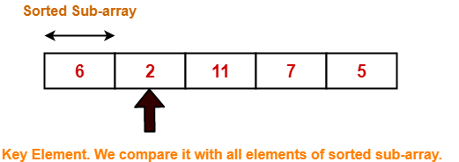

Step-02: For i = 2

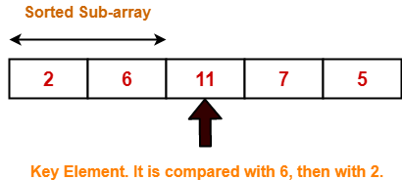

Step-03: For i = 3

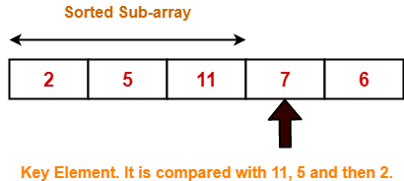

2 | 5 | 11 | 7 | 6 |  | For j = 2; 11 > 7 so A[3] = 11
2 | 5 | 11 | 11 | 6 |  | For j = 1; 5 < 7 so loop stops and A[2] = 7
2 | 5 | 7 | 11 | 6 |  | After inner loop ends

Working of inner loop when i = 3

Step-04: For i = 4

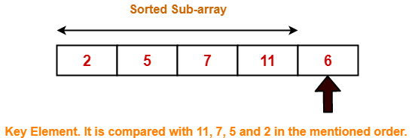

Loop gets terminated as ‘i’ becomes 5. The state of array after the loops are finished-

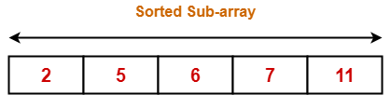

With each loop cycle,
- One element is placed at the correct location in the sorted sub-array until array A is completely sorted.

Time Complexity Analysis-

- Selection sort algorithm consists of two nested loops.
- Owing to the two nested loops, it has O(n²) time complexity.

 | Time Complexity
Best Case | n
Average Case | n²
Worst Case | n²

Space Complexity Analysis-

- Selection sort is an in-place algorithm.
- It performs all computation in the original array and no other array is used.
- Hence, the space complexity works out to be O(1).

Important Notes-

- Insertion sort is not a very efficient algorithm when data sets are large.
- This is indicated by the average and worst case complexities.
- Insertion sort is adaptive and number of comparisons are less if array is partially sorted.

Selection Sort-

- Selection sort is one of the easiest approaches to sorting.
- It is inspired from the way in which we sort things out in day to day life.
- It is an in-place sorting algorithm because it uses no auxiliary data structures while sorting.

How Selection Sort Works?

Consider the following elements are to be sorted in ascending order using selection sort-
6, 2, 11, 7, 5

Selection sort works as-
- It finds the first smallest element (2).
- It swaps it with the first element of the unordered list.
- It finds the second smallest element (5).
- It swaps it with the second element of the unordered list.
- Similarly, it continues to sort the given elements.

As a result, sorted elements in ascending order are-
2, 5, 6, 7, 11

Selection Sort Algorithm-

Let A be an array with n elements. Then, selection sort algorithm used for sorting is as follows-

for (i = 0 ; i < n-1 ; i++)
{
index = i;
for(j = i+1 ; j < n ; j++)
{
if(A[j] < A[index])
index = j;
}
temp = A[i];
A[i] = A[index];
A[index] = temp;
}

Here,
- i = variable to traverse the array A
- index = variable to store the index of minimum element
- j = variable to traverse the unsorted sub-array
- temp = temporary variable used for swapping

Selection Sort Example-

Consider the following elements are to be sorted in ascending order-
6, 2, 11, 7, 5

The above selection sort algorithm works as illustrated below-

Step-01: For i = 0

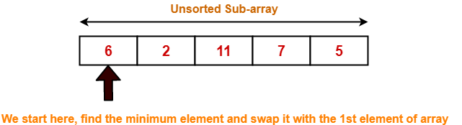

Step-02: For i = 1

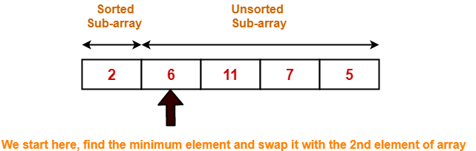

Step-03: For i = 2

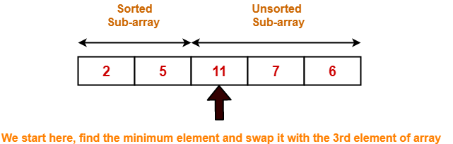

Step-04: For i = 3

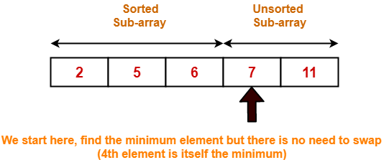

Step-05: For i = 4

Loop gets terminated as ‘i’ becomes 4.

The state of array after the loops are finished is as shown-

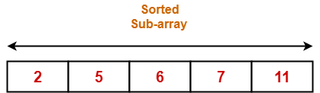

With each loop cycle,
- The minimum element in unsorted sub-array is selected.
- It is then placed at the correct location in the sorted sub-array until array A is completely sorted.

Time Complexity Analysis-

- Selection sort algorithm consists of two nested loops.
- Owing to the two nested loops, it has O(n²) time complexity.

 | Time Complexity
Best Case | n²
Average Case | n²
Worst Case | n²

Space Complexity Analysis-

- Selection sort is an in-place algorithm.
- It performs all computation in the original array and no other array is used.
- Hence, the space complexity works out to be O(1).

Important Notes-

- Selection sort is not a very efficient algorithm when data sets are large.
- This is indicated by the average and worst case complexities.
- Selection sort uses minimum number of swap operations O(n) among all the sorting algorithms.

Quick Sort-

- Quick Sort is a famous sorting algorithm.
- It sorts the given data items in ascending order.
- It uses the idea of divide and conquer approach.
- It follows a recursive algorithm.

Quick Sort Algorithm-
- a = Linear Array in memory
- beg = Lower bound of the sub array in question
- end = Upper bound of the sub array in question

Then, Quick Sort Algorithm is as follows-

Partition_Array (a , beg , end , loc)
Begin
Set left = beg , right = end , loc = beg
Set done = false
While (not done) do
While ( (a[loc] <= a[right] ) and (loc ≠ right) ) do
Set right = right - 1
end while
if (loc = right) then
Set done = true
else if (a[loc] > a[right]) then
Interchange a[loc] and a[right]
Set loc = right
end if
if (not done) then
While ( (a[loc] >= a[left] ) and (loc ≠ left) ) do
Set left = left + 1
end while
if (loc = left) then
Set done = true
else if (a[loc] < a[left]) then
Interchange a[loc] and a[left]
Set loc = left
end if
end if
end while
End

How Does Quick Sort Works?

- Quick Sort follows a recursive algorithm.
- It divides the given array into two sections using a partitioning element called as pivot.

The division performed is such that-

- All the elements to the left side of pivot are smaller than pivot.
- All the elements to the right side of pivot are greater than pivot.

After dividing the array into two sections, the pivot is set at its correct position.
Then, sub arrays are sorted separately by applying quick sort algorithm recursively.

Quick Sort Example-

Consider the following array has to be sorted in ascending order using quick sort algorithm-

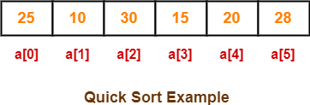

Quick Sort Algorithm works in the following steps-

Step-01:

Initially-
- Left and Loc (pivot) points to the first element of the array.
- Right points to the last element of the array.

So to begin with, we set loc = 0, left = 0 and right = 5 as-

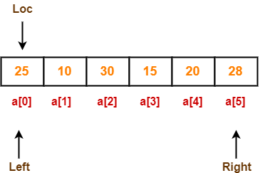

Step-02:

Since loc points at left, so algorithm starts from right and move towards left.
As a[loc] < a[right], so algorithm moves right one position towards left as-

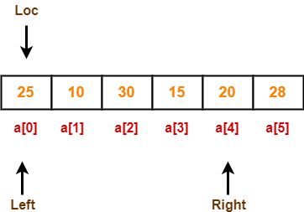

Now, loc = 0, left = 0 and right = 4.

Step-03:

Since loc points at left, so algorithm starts from right and move towards left.
As a[loc] > a[right], so algorithm swaps a[loc] and a[right] and loc points at right as-

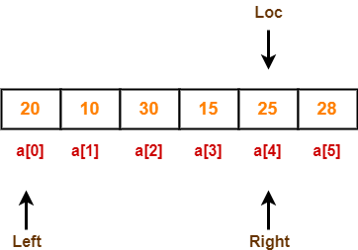

Now, loc = 4, left = 0 and right = 4.

Step-04:

Since loc points at right, so algorithm starts from left and move towards right.
As a[loc] > a[left], so algorithm moves left one position towards right as-

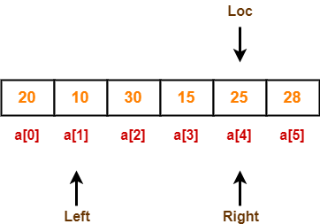

Now, loc = 4, left = 1 and right = 4.

Step-05:

Since loc points at right, so algorithm starts from left and move towards right.
As a[loc] > a[left], so algorithm moves left one position towards right as-

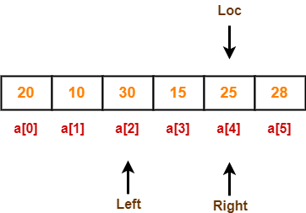

Now, loc = 4, left = 2 and right = 4.

Step-06:

Since loc points at right, so algorithm starts from left and move towards right.
As a[loc] < a[left], so we algorithm swaps a[loc] and a[left] and loc points at left as-

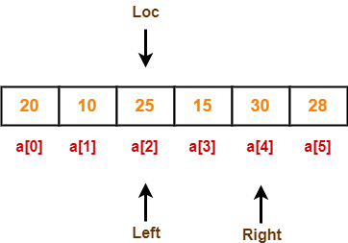

Now, loc = 2, left = 2 and right = 4.

Step-07:

Since loc points at left, so algorithm starts from right and move towards left.
As a[loc] < a[right], so algorithm moves right one position towards left as-

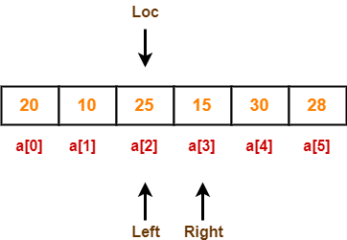

Now, loc = 2, left = 2 and right = 3.

Step-08:

Since loc points at left, so algorithm starts from right and move towards left.
As a[loc] > a[right], so algorithm swaps a[loc] and a[right] and loc points at right as-

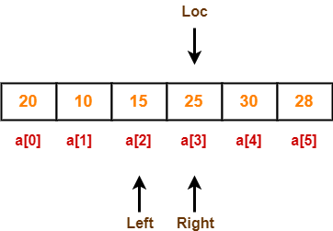

Now, loc = 3, left = 2 and right = 3.

Step-09:

Since loc points at right, so algorithm starts from left and move towards right.
As a[loc] > a[left], so algorithm moves left one position towards right as-

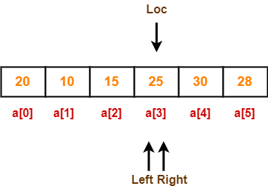

Now, loc = 3, left = 3 and right = 3.

Now,
- loc, left and right points at the same element.
- This indicates the termination of procedure.
- The pivot element 25 is placed in its final position.
- All elements to the right side of element 25 are greater than it.
- All elements to the left side of element 25 are smaller than it.

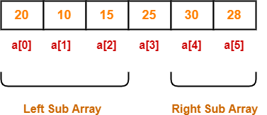

Now, quick sort algorithm is applied on the left and right sub arrays separately in the similar manner.

Quick Sort Analysis-

- To find the location of an element that splits the array into two parts, O(n) operations are required.
- This is because every element in the array is compared to the partitioning element.
- After the division, each section is examined separately.
- If the array is split approximately in half (which is not usually), then there will be log₂n splits.
- Therefore, total comparisons required are f(n) = n x log₂n = O(nlog₂n).

Order of Quick Sort = O(nlog₂n)

Worst Case-

- Quick Sort is sensitive to the order of input data.
- It gives the worst performance when elements are already in the ascending order.
- It then divides the array into sections of 1 and (n-1) elements in each call.
- Then, there are (n-1) divisions in all.
- Therefore, here total comparisons required are f(n) = n x (n-1) = O(n²).

Order of Quick Sort in worst case = O(n²)

Advantages of Quick Sort-

The advantages of quick sort algorithm are-
- Quick Sort is an in-place sort, so it requires no temporary memory.
- Quick Sort is typically faster than other algorithms.
(because its inner loop can be efficiently implemented on most architectures)
- Quick Sort tends to make excellent usage of the memory hierarchy like virtual memory or caches.
- Quick Sort can be easily parallelized due to its divide and conquer nature.

Disadvantages of Quick Sort-

The disadvantages of quick sort algorithm are-
- The worst case complexity of quick sort is O(n²).
- This complexity is worse than O(nlogn) worst case complexity of algorithms like merge sort, heap sort etc.
- It is not a stable sort i.e. the order of equal elements may not be preserved.

HEAP SORT
Heap sort is a comparison based sorting technique based on Binary Heap data structure. It is similar to selection sort where we first find the maximum element and place the maximum element at the end. We repeat the same process for the remaining elements.
What is Binary Heap?
Let us first define a Complete Binary Tree. A complete binary tree is a binary tree in which every level, except possibly the last, is completely filled, and all nodes are as far left as possible (Source Wikipedia)
A Binary Heap is a Complete Binary Tree where items are stored in a special order such that value in a parent node is greater(or smaller) than the values in its two children nodes. The former is called as max heap and the latter is called min-heap. The heap can be represented by a binary tree or array.
Why array based representation for Binary Heap?
Since a Binary Heap is a Complete Binary Tree, it can be easily represented as an array and the array-based representation is space-efficient. If the parent node is stored at index I, the left child can be calculated by 2 * I + 1 and right child by 2 * I + 2 (assuming the indexing starts at 0).
Heap Sort Algorithm for sorting in increasing order:
1. Build a max heap from the input data.
2. At this point, the largest item is stored at the root of the heap. Replace it with the last item of the heap followed by reducing the size of heap by 1. Finally, heapify the root of the tree.
3. Repeat step 2 while size of heap is greater than 1.
How to build the heap?
Heapify procedure can be applied to a node only if its children nodes are heapified. So the heapification must be performed in the bottom-up order.
Lets understand with the help of an example:
Input data: 4, 10, 3, 5, 1
4(0)
/ \
10(1) 3(2)
/ \
5(3) 1(4)

The numbers in bracket represent the indices in the array
representation of data.

Applying heapify procedure to index 1:
4(0)
/ \
10(1) 3(2)
/ \
5(3) 1(4)

Applying heapify procedure to index 0:
10(0)
/ \
5(1) 3(2)
/ \
4(3) 1(4)
The heapify procedure calls itself recursively to build heap
in top down manner.

SHELL SORT
ShellSort is mainly a variation of Insertion Sort. In insertion sort, we move elements only one position ahead. When an element has to be moved far ahead, many movements are involved. The idea of shellSort is to allow exchange of far items. In shellSort, we make the array h-sorted for a large value of h. We keep reducing the value of h until it becomes 1.
Shell sort is an algorithm that first sorts the elements far apart from each other and successively reduces the interval between the elements to be sorted. It is a generalized version of insertion sort.
In shell sort, elements at a specific interval are sorted. The interval between the elements is gradually decreased based on the sequence used. The performance of the shell sort depends on the type of sequence used for a given input array.

Some of the optimal sequences used are:
- Shell's original sequence: N/2 , N/4 , …, 1
- Knuth's increments: 1, 4, 13, …, (3k – 1) / 2

Time Complexity: Time complexity of above implementation of shellsort is O(n²). In the above implementation gap is reduce by half in every iteration. There are many other ways to reduce gap which lead to better time complexity.

How Shell Sort Works?
- Suppose, we need to sort the following array.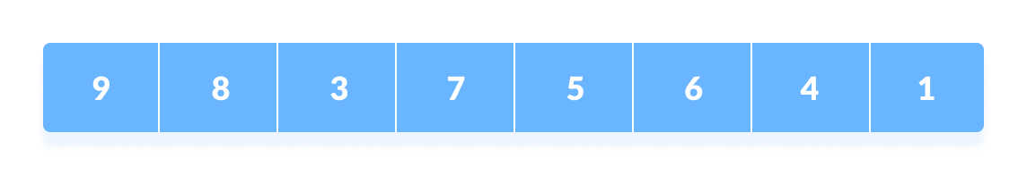Initial array
- We are using the shell's original sequence (N/2, N/4, ...1) as intervals in our algorithm.
In the first loop, if the array size is N = 8 then, the elements lying at the interval of N/2 = 4 are compared and swapped if they are not in order.
  - The 0th element is compared with the 4th element.
  - If the 0th element is greater than the 4th one then, the 4th element is first stored in temp variable and the 0th element (ie. greater element) is stored in the 4th position and the element stored in temp is stored in the 0th position.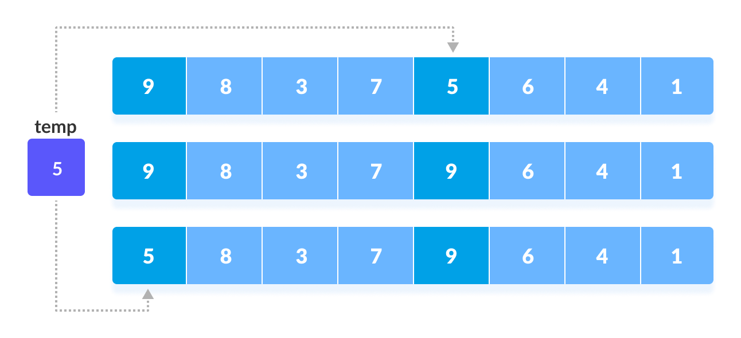Rearrange the elements at n/2 interval
This process goes on for all the remaining elements.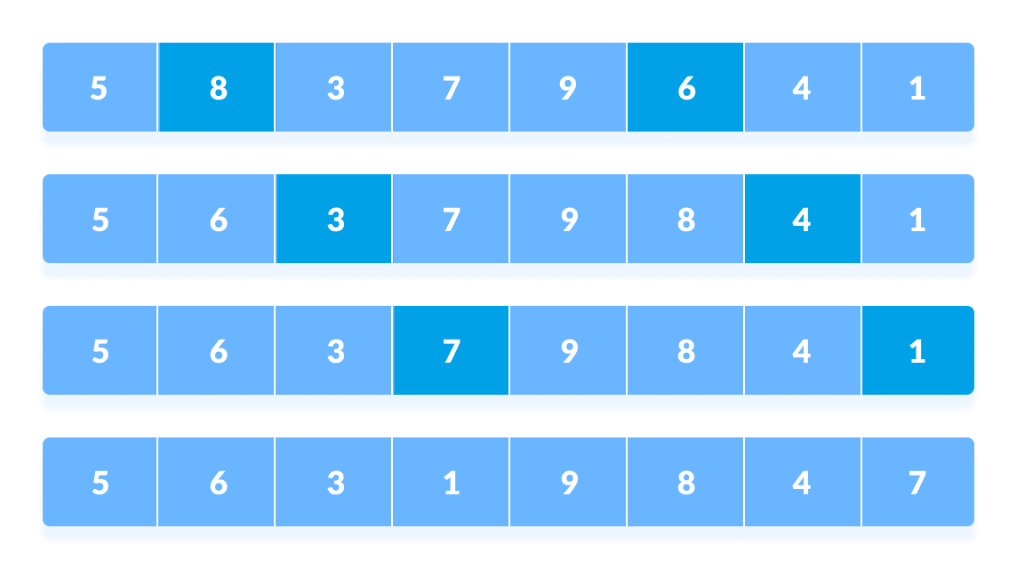Rearrange all the elements at n/2 interval
- In the second loop, an interval of N/4 = 8/4 = 2 is taken and again the elements lying at these intervals are sorted.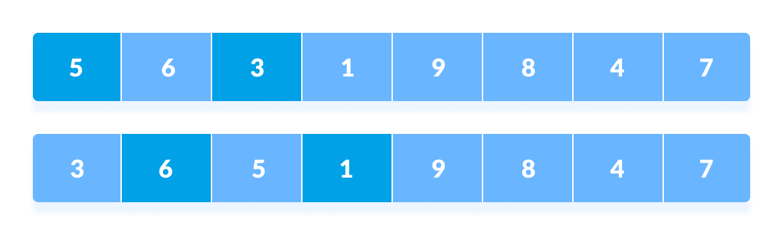Rearrange the elements at n/4 interval
You might get confused at this point.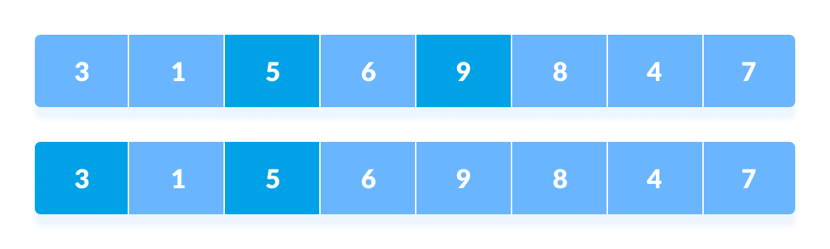All the elements in the array lying at the current interval are compared.
The elements at 4th and 2nd position are compared. The elements at 2nd and 0th position are also compared. All the elements in the array lying at the current interval are compared.
- The same process goes on for remaining elements.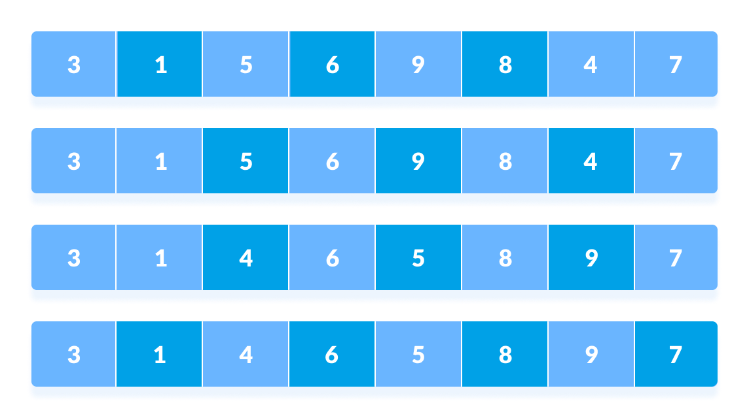Rearrange all the elements at n/4 interval
- Finally, when the interval is N/8 = 8/8 =1 then the array elements lying at the interval of 1 are sorted. The array is now completely sorted.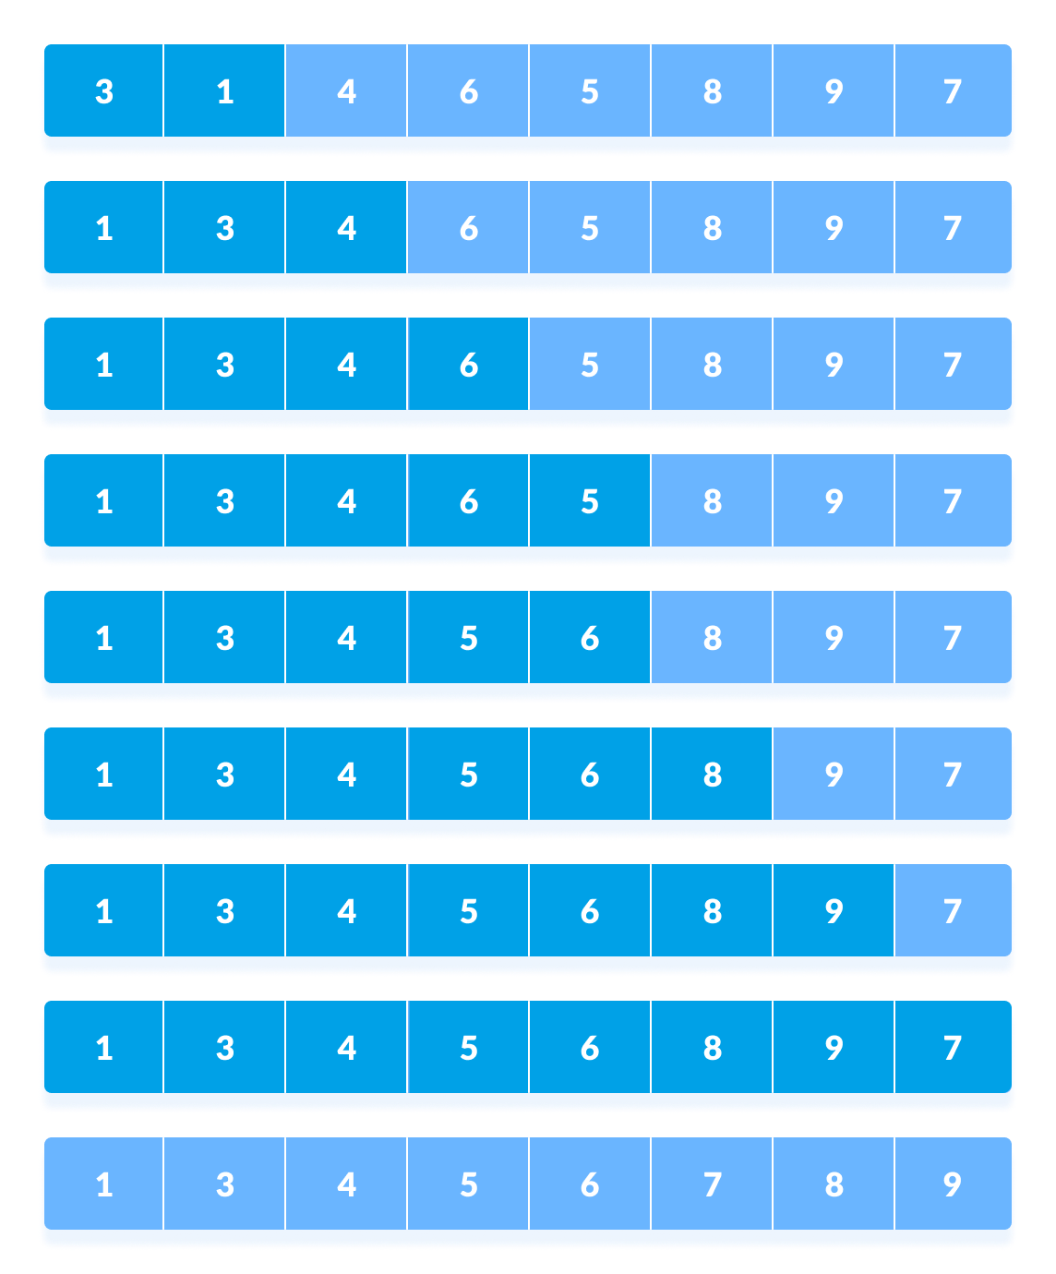Rearrange the elements at n/8 interval

